**Дата**: 24.09.2024

**Клас**: 5-Б

**Предмет**: Англійська мова

**Тема:** У новій школі.

**Мета:** : формувати навички вживання лексичних одиниць по темі; удосконалювати навички читання, аудіювання й усного монологічного мовлення; розвивати пізнавальні інтереси учнів; виховувати інтерес до самостійного пошуку потрібної інформації, а також загальну культуру учнів.

**Вчитель**: Руда Д.В.

Хід уроку

1.Greeting

Good afternoon, dear children! I’m glad to see you. Are you ready to start our

lesson? All set?

2. Wаrm up / Listening

Уважно слухати аудіо трек і дати відповідь на питання вчителя <https://www.youtube.com/watch?v=7isSwerYaQc&t=179s>.

3. Speaking

When did you start school? Do you remember your first day?

How far did you have to travel from home to school? How did you get to school?

Did you enjoy school life? What did you like and dislike about it?

Who was your favorite teacher? What do you remember about him or her?

What was your favorite subject at school? Why?

Did you have to wear a uniform to school? If so, what did yours look like?

What are the pros and cons of uniforms for school kids?

How many children were there in your class? What is the best number of students for a class?

Did you go to any academies or receive any tutoring outside of your main school? Is extra education like that necessary?

What did you and your classmates do during your lunch break?

Was there bullying at your school? Did you have to deal with any bullies?

4. Повторення

Повторення Present Simple / Present Continuous..

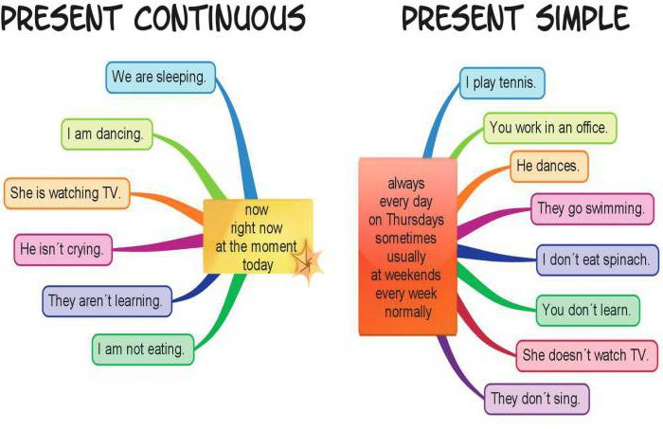

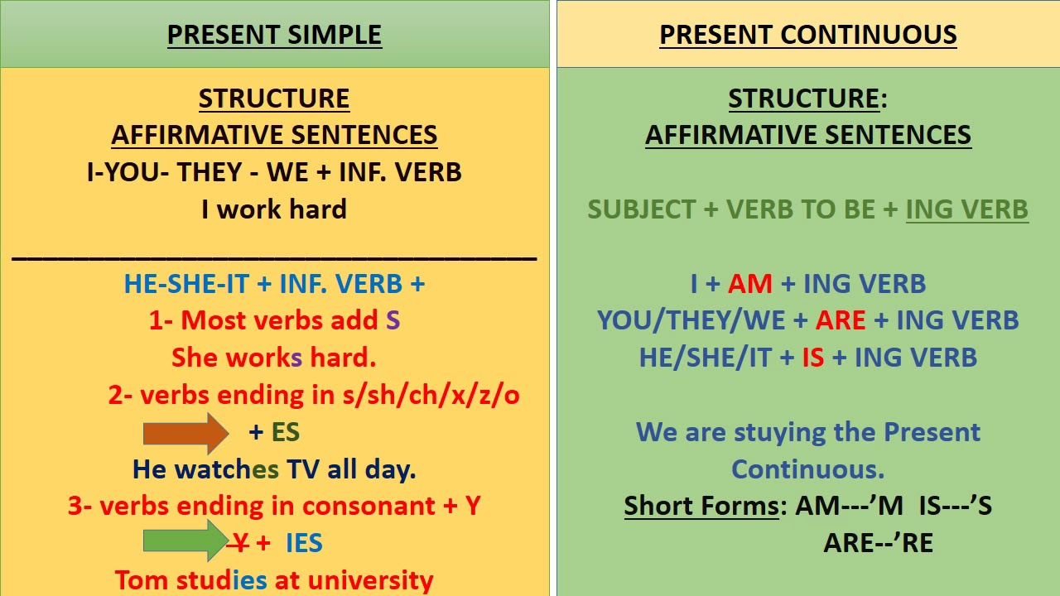

5. Writing

Впр 9 стр 23.

6. Homework

1. Письмово виконати вправу 10 стр 23.